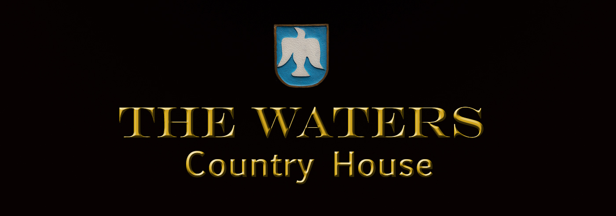

Terms and Conditions
Welcome to the website of The Waters Country House, Ballyvaughan, Co. Clare, Ireland. PLEASE READ CAREFULLY BEFORE YOU BOOK.

- Reservation Deposit To make an accommodation reservation you must: enter correct contact details and pay a non refundable deposit of 5% of the total package price. This non-refundable 5% booking deposit will be debited from your card at the time of booking. In the event that the booking deposit cannot be debited from your card then such reservation shall be deemed null and void. The balance and remaining charge as well as any additional costs incurred shall be paid directly to The Waters Country House prior to departure.
- Cancellation Policy The Waters Country House cancellation policy is 24 hours prior to noon GMT on the day of arrival unless previous cancellation terms have been negotiated. Non arrivals or late cancellations will be liable for the balance of accommodation charge for the first night of the entire booking. These charges will be applied to the credit card guaranteeing the booking. Rates are quoted in the currency of the day and are subject to fluctuations. All rates quoted are fully inclusive of local taxes. There is no service charge. The Waters Country House reserves the right to cancel this contract in the event of circumstances arising outside of our control. While every effort has been made to ensure the accuracy of all information, we do not accept liability for any errors or omissions and reserve the right to change our information and descriptions. To cancel a reservation, you will need to retrieve the reservation reference you wish to cancel. Using this reservation/confirmation number and your date of arrival we ask that you contact the reservations department by telephone to cancel your booking. Please read the terms and conditions linked to your booking prior to canceling the booking.
- Arrival Time The expected time of arrival is after 15.00 hrs.. Please telephone reception in advance if arrival time is after 6.00pm otherwise room availability can not be guaranteed. The expected time of departure is before 12.00 noon. Any alterations to these times must be arranged with The Waters Country House prior to arrival.
- Prices and Information Unless specifically stated, rates quoted do not include additional requirements. While every effort is made to ensure accuracy of information The Waters Country House accepts no responsibility for errors or omissions in the provision of information, nor accepts any liabilities for loss, injury, damage, delay, expense or inconvenience whatsoever in relation to the provision of the information.
- Obligations of The Waters Country House, Ballyvaughan, Co. Clare, Ireland. The Waters Country House agrees to furnish the accommodation package as set out in the reservation form. This will constitute the entire agreement between The Waters Country House and the client. Each rate has its own specific rate description which details exactly what is included in that rate. Please ensure you check this and are happy with rate booked before confirming reservation.
- Liability of The Waters Country House, Ballyvaughan, Co. Clare, Ireland The Waters Country House shall be solely liable to you for any loss that you may suffer in connection with the accommodation reservation. If the Accommodation that you reserved is not available, it is the responsibility of the property to ensure that suitable equivalent accommodation of a similar or higher standard is arranged for you and transport is arranged to such alternative accommodation.
- Limitation of Liability of the Provider The liability of The Waters Country House shall not exceed the total price for the accommodation as specified on the reservation form. In no event will the property be liable for any indirect or consequential loss by you. You agree to indemnify and hold harmless the Accommodation Provider against all costs or damages whether direct or indirect arising from any acts or omissions by you.
- Complaints Procedure All complaints, in relation to accommodation, facilities, or additional requirements should be made in writing to The Waters Country House within two weeks of the event of the complaint. Every effort will be made to settle a complaint but in the event that this procedure does not satisfy your complaint will be referred to the decision of a single arbitrator appointed by agreement between both parties. If an arbitrator cannot be agreed upon, the President for the time being of the Incorporated Law Society of Ireland will appoint the arbitrator. The Arbitration Acts, 1954 to 1980 and any statutory amendment or reenactment thereof will apply to such arbitration. No legal action can commence without initiating the procedure above.

